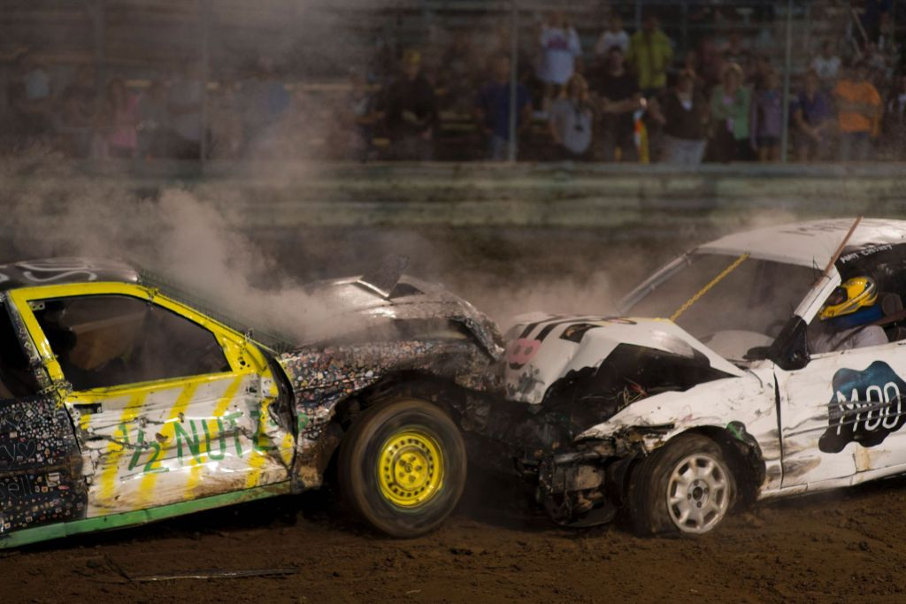**2025 NSHMA**

**Demolition Derby Sponsorship**

The New Sarepta Minor Hockey Association is proud to present their annual Demolition Derby on Saturday September 6th, 2025. This is the largest fundraiser for our communities Minor Hockey Association.

With your support and sponsorship, together we can make this a successful event!

For further information please feel free to contact:

Dennis Levasseur (780) 975-5302 or Lindsay Weissenborn (780) 721-4629

Thank you in advance for your consideration! We hope to see you there!

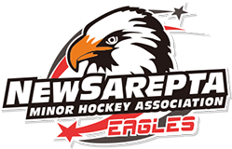**Main Event Sponsor-$5000+**

Would your company like to be our Main Event Sponsor? Let the community and surrounding communities know that you are one of their biggest supporters. Included in this package is:

VIP Parking (Max 4 vehicles), VIP Seating, 2 blocks for advertising, Company Logo on our U18 team jerseys to be worn for the 2025-2026 season, Wait Staff Services, 5 hoodies, 3 T-shirts, 10 Entry tickets, company banner display, 10 food vouchers for Burger or hot dog at our Derby Concession and unlimited drinks from our Derby Concession.

Prime Plus-$3000+

VIP Parking (Max 4 vehicles), VIP Seating, 1 block for advertising, Company Logo on our U15 team jerseys to be worn for the 2025-2026 season, Wait Staff Services, 3 hoodies, 3 T-shirts, 10 Entry tickets, company banner display, 10 food vouchers for Burger or hot dog at our Derby Concession and unlimited drinks from our Derby Concession.

Prime-$2500+

VIP Parking (Max 4 vehicles), VIP Seating, 1 block for advertising, Wait Staff Services, 2 hoodies, 3 T-shirts, 10 Entry tickets, company banner display, 10 food vouchers for Burger or hot dog at our Derby Concession and unlimited drinks from our Derby Concession.

Executive Plus-$2000+

VIP Parking (Max 4 vehicles), VIP Seating, 1 block for advertising, Wait Staff Services, 1 hoodie, 2 T-shirts, 10 Entry tickets, company banner display, 10 food vouchers for Burger or hot dog at our Derby Concession and unlimited drinks from our Derby Concession

Executive- $1500+

VIP Seating, Wait Staff Services, 4 T-shirts, 8 Entry tickets, company banner display, 8 food vouchers for Burger or hot dog at our Derby Concession and 8 drink tickets for our Derby Concession.

Platinum-$1000+

VIP Seating, Wait Staff Services, 2 T-shirts, 6 Entry tickets, company banner display, 6 food vouchers for Burger or hot dog at our Derby Concession and 6 drink tickets for our Derby Concession.

Gold-$800+

VIP Seating, 6 Entry tickets, company banner display, 6 food vouchers for Burger or hot dog at our Derby concession and 6 drink tickets for our Derby Concession.

Silver-$400+

4 Entry tickets, company banner display, 2 food vouchers for Burger or hot dog at our Derby concession and 4 drink tickets for our Derby Concession.

Bronze-$300+

2 Entry tickets, company banner display.



Friends-Donations

Name drop from our announcer through out the show!

PAYMENT OPTIONS:

* CHQ’s can be made out to: NSMHA Mailed to: Box 215 New Sarepta, AB T0B3M2
* EMT can be sent to: [treasurer.nsmha@gmail.com](mailto:treasurer.nsmha@gmail.com)

****(Please include your Business name. Password: Derby2025)

* Credit card accepted-Signed Credit Card authorization form required.

2025 Sponsorship Public Relation form

Contact Information

|  |  |
| --- | --- |
| Company Name: |  |
| Owners: |  |
| Address: |  |
| Email: |  |
| Phone: |  |
| Type of Business: |  |
| Sponsorship Level: |  |
| Personal Connection to Community/Association: |  |
| T-Shirt/Hoodies *If your sponsorship level includes these items please include the sizes you would like. XS, S, M, L, XL, XXL, XXXL |  |

Sponsorship Public Relation Form and your company Logo can be submitted to: [fundraiser.nsmha@gmail.com](mailto:fundraiser.nsmha@gmail.com)

NSMHA would like to extend a heartfelt thank you for your support!

**New Sarepta Minor Hockey Association**

**Box 215**

**New Sarepta, AB T0B3M0**

**Credit Card Approval and Signature Authorization Form**

This form is required for us to be able to charge your credit card for sponsorship/donation to the 2025 New Sarepta Demolition Derby. This form ensures we are doing all that we can to avoid fraudulent charges to credit cards. We appreciate your willingness and understanding to sign this form and return to us.

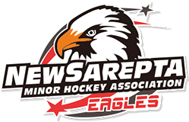

Credit Card #:________________________________________________________

Credit Card Issuer:______________________________ (Ie. Mastercard, Visa)

Expiration Date:___________________________________________________

Security Code (3 digits on the back of the card):_________________________

Name as it appears on car:____________________________________________

Billing address of card:________________________________________________

Postal Code for billing address:__________________________

Amount authorized to charge card shown above:______________________ ($CDN)

*By signing below you authorize New Sarepta Minor Hockey to charge this credit card for the amount shown above. You also hereby guarantee payment of the amount shown above.

____________________________________ ________________________________

Card Holders Signature Date

treasurer.nsmha@gmail.com